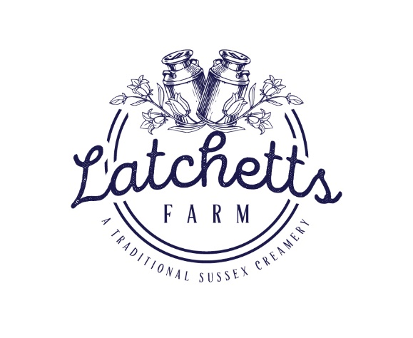Salted Caramel

Ingredients:

BASE Emulsifier E471, thickeners (tara gum, sodium alginate, guar gum), **MILK** protein, Salt, Sugar, Dextrose, Glucose, Skimmed **MILK** powder, Whole **MILK, CREAM**. Glucose syrup, sweetened condensed skimmed **MILK**, sugar, water, cocoa butter, modified starch, thickener: agar-agar (E406), flavours, emulsifiers: mono- and diglycerides of fatty acids (E471) and sunflower lecithin (E322), salt, acidity regulator: citric acid (E330), preservative: potassium sorbate (E202)

For allergens see ingredients in **BOLD**

May contain SOYBEANS, MILK, EGG, ALMONDS, HAZLENUTS, WALNUTS, PISTACHIO, PEANUTS, SESAME SEEDS

**V**

***Suitable for vegetarians***

***STORAGE***

*Keep Frozen at -18 or cooler*

*IMPORTANT: if food has thawed,* ***DO NOT REFREEZE***

*BBE: Side of Tub & Lid*

***RECYLING***

***LID- PLASTIC-*** *check local recycling* ***TUB- PLASTIC-*** *check local recycling*

*Produced in the UK by;*

*Latchetts Farm LTD, Heaven Farm, Furners Green, Uckfield, TN223RG.*